PNEUMONIA DETECTION USING DEEP LEARNING
Design and Implementation
Department of Computer Science and Engineering, TKR College of Engineering and Technology (Autonomous)
Batch A12 (CSE-A) · Academic year 2026-2027
Table 1: Project team
S.No. | Student name | Roll number
1 | CHOUDAM AKSHITHA | 23K91A0556
2 | BOGGULA SATVIK KUMAR | 23K91A0541
3 | ARUTLA ABHI THEJ REDDY | 23K91A0515
4 | DUGGARAJU LIKHITHA | 23K91A0565

Project guide: V. MEENAKSHI
Chapter and section numbers quoted in the text (for example Section 6.6 or Chapter 8) refer to the full project report, 17.Final Document. Figures and tables in this document are numbered from 1.

1. DESIGN

5.1 Architecture
The design follows two rules: do not rewrite what already works, and keep each layer replaceable. The model, Grad-CAM and database modules of the original Flask project are reused as they are; the FastAPI layer and the React interface sit on top of them.
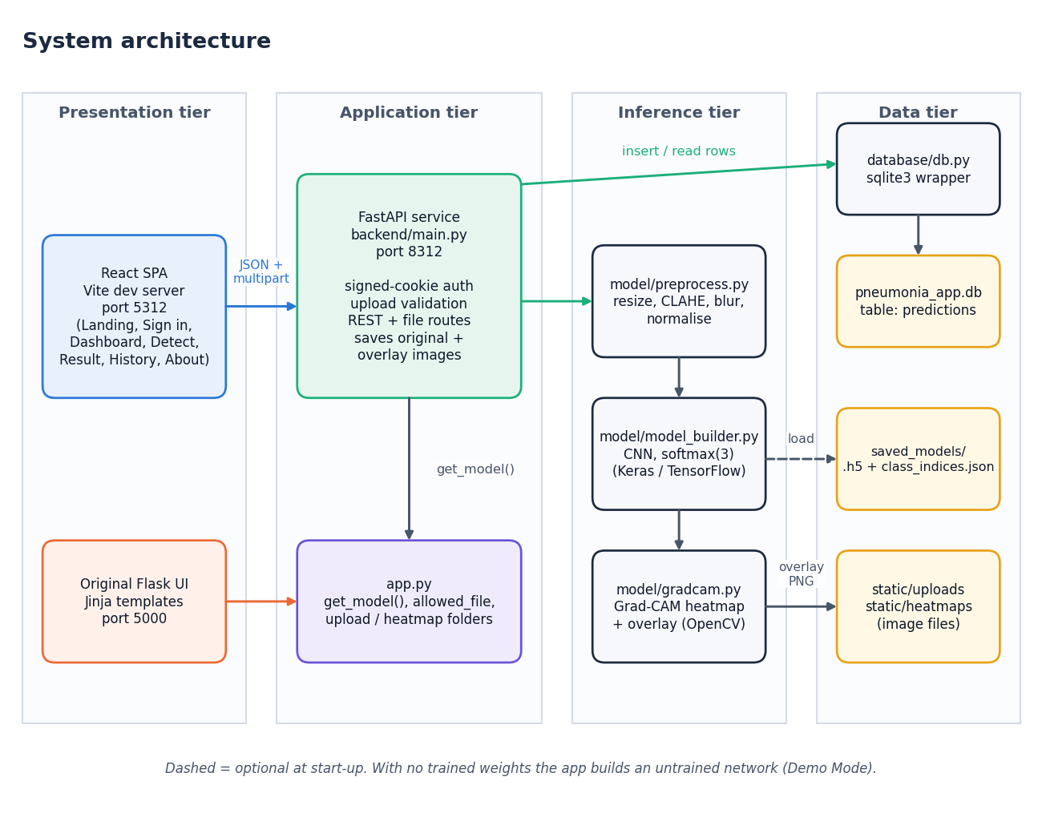
Figure 1: System architecture of the pneumonia detection system
The system has four tiers. In the presentation tier the React single-page application (served by the Vite development server on port 5312) and the original Flask interface (port 5000) are the two ways a user reaches the system. The application tier is the FastAPI service in backend/main.py (port 8312), which authenticates the session cookie, validates uploads and exposes the REST and file routes; it imports app.py for the model loader and folder settings, so the model is loaded once and shared. The inference tier is the three modules that do the actual work: preprocess.py turns an upload into a 224 x 224 tensor, model_builder.py defines the CNN and gradcam.py produces the heat map. The data tier holds the SQLite database (pneumonia_app.db, table predictions), the saved original and overlay images, and the trained weights. When saved_models/ holds no weights the loader builds an untrained network and flags Demo Mode.

5.2 High-level workflow
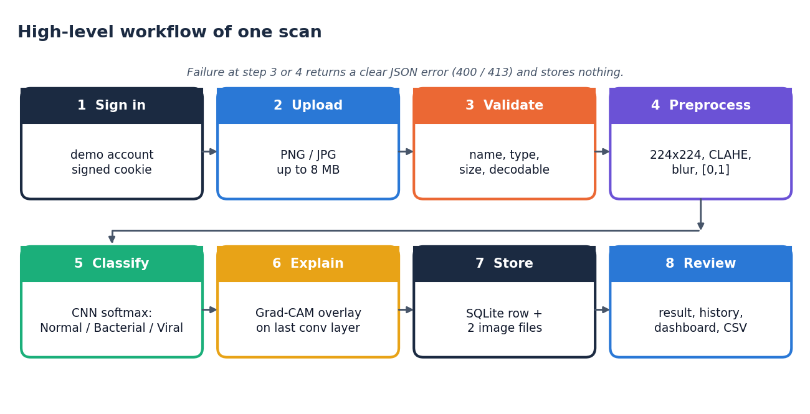
Figure 2: High-level workflow of one scan, from sign-in to review
A scan passes through eight steps. The user signs in, uploads a PNG or JPEG of at most 8 MB, and the server validates the name, type, size and that the file can be decoded. The image is preprocessed (224 x 224, CLAHE, light blur, scaling to [0, 1]) and classified by the CNN, whose softmax output gives the three class probabilities. Grad-CAM then explains the predicted class, and the record plus the two image files are stored. Finally the user reviews the result, the history and the dashboard. A failure at the validation or decoding step ends the flow with a JSON error and stores nothing.

5.3 Data flow diagrams

Level 0
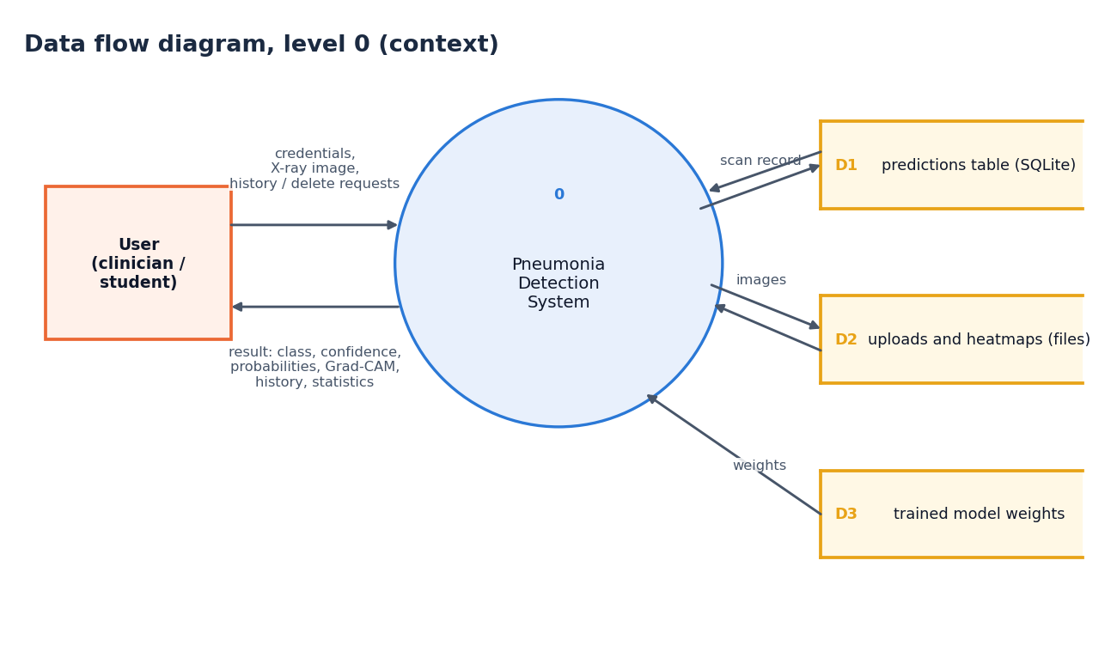
Figure 3: Data flow diagram, level 0 (context diagram)
The context diagram shows the system as a single process with one external entity, the user. The user sends credentials, X-ray images and history or delete requests; the system returns the classification result with its heat map, the history and the statistics. Internally the system reads and writes three data stores: the predictions table (D1), the uploaded and heat-map image files (D2) and the trained model weights (D3), which are only read.

Level 1
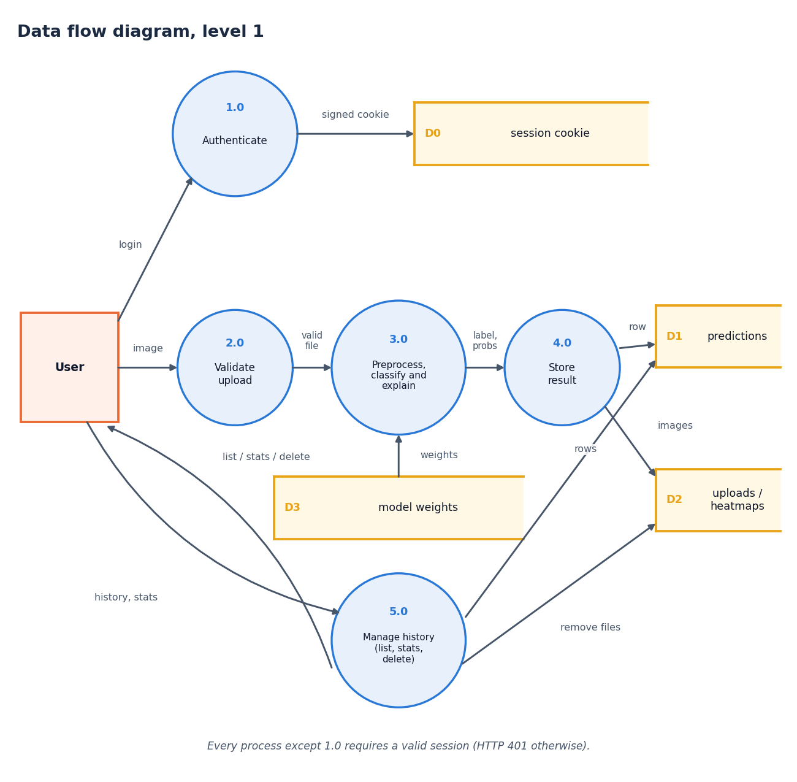
Figure 4: Data flow diagram, level 1
Level 1 splits the system into five processes. Authenticate (1.0) checks the credentials and sets a signed cookie (D0). Validate upload (2.0) accepts the image only if the cookie is valid, the extension is allowed, the size is within 8 MB and the file decodes. Preprocess, classify and explain (3.0) reads the model weights (D3) and returns the label, probabilities and overlay. Store result (4.0) writes one row to the predictions table (D1) and the two images to the file store (D2). Manage history (5.0) serves the list, the statistics and deletions, and removes the image files when a scan is deleted.

Level 2
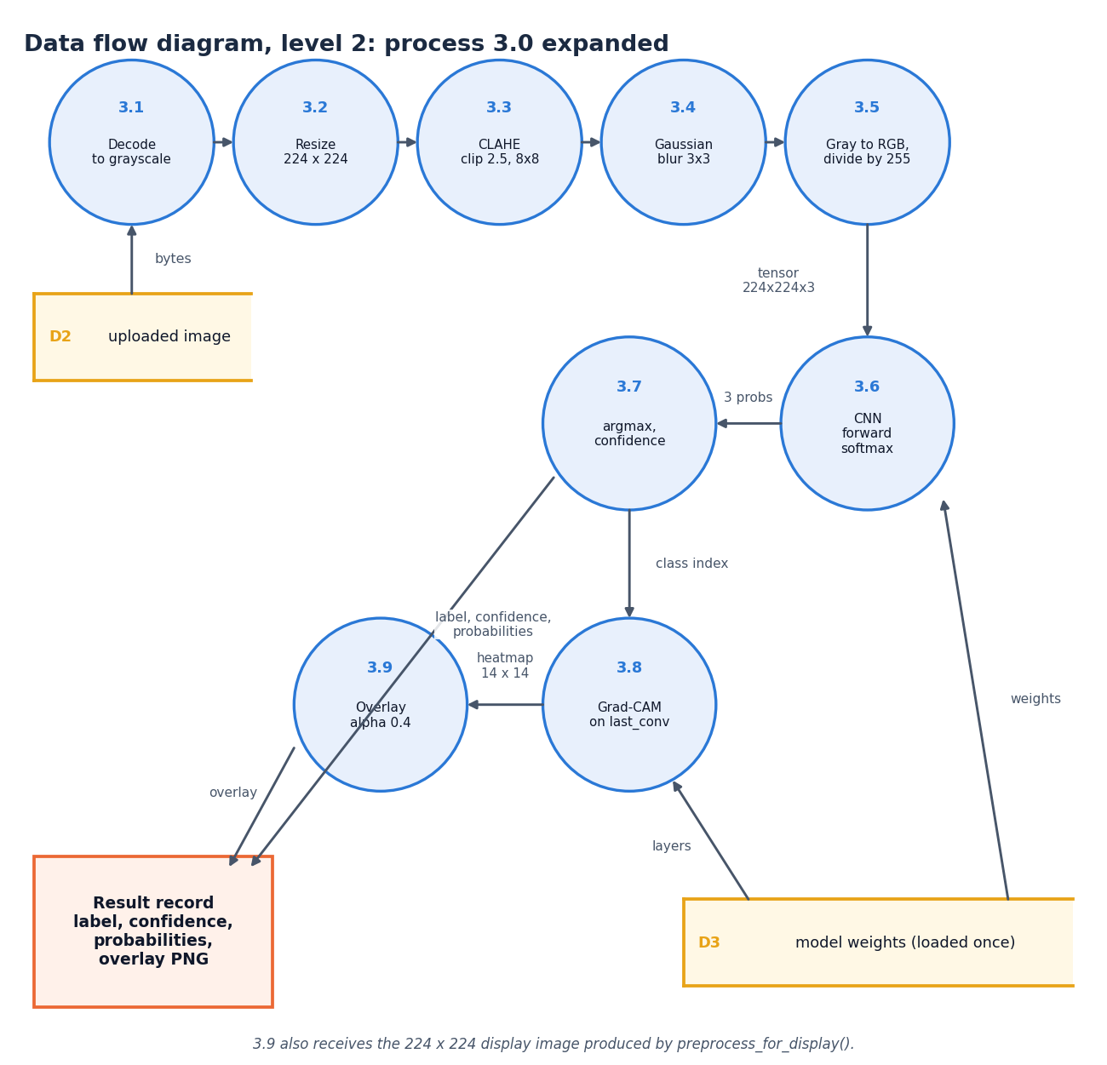
Figure 5: Data flow diagram, level 2: process 3.0 expanded
Level 2 expands the inference process into its nine steps, in the order the code executes them. The upload is decoded to grayscale (3.1), resized to 224 x 224 (3.2), enhanced with CLAHE (clip limit 2.5, 8 x 8 tiles; 3.3), smoothed with a 3 x 3 Gaussian (3.4) and converted to three channels scaled to [0, 1] (3.5). The network produces three probabilities (3.6); the arg-max and its probability become the label and confidence (3.7). The class index drives Grad-CAM on the last convolutional layer (3.8), whose 14 x 14 map is blended at alpha 0.4 over the display image (3.9). The result record carries the label, confidence, probabilities and the overlay image.

5.4 UML diagrams

Class diagram
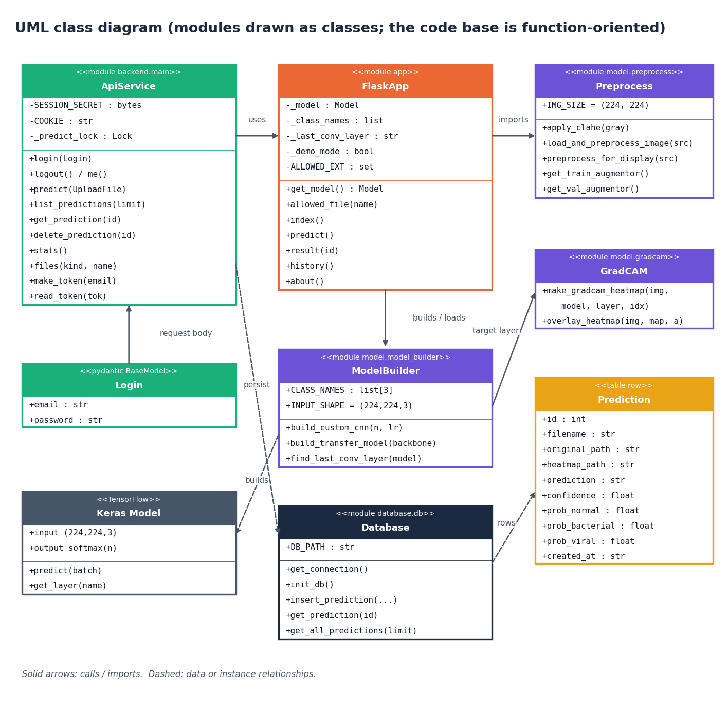
Figure 6: UML class diagram (modules drawn as classes)
The code base is function-oriented, so the diagram draws each Python module as a class stereotyped as a module, listing its constants and public functions. ApiService (backend/main.py) uses FlaskApp (app.py) for the model loader and imports Preprocess; FlaskApp builds or loads the network through ModelBuilder, which creates Keras models, and GradCAM receives the name of the last convolutional layer from ModelBuilder. Database persists Prediction rows. Login is the only real class in the API layer (a Pydantic model that validates the sign-in body).

Sequence diagram
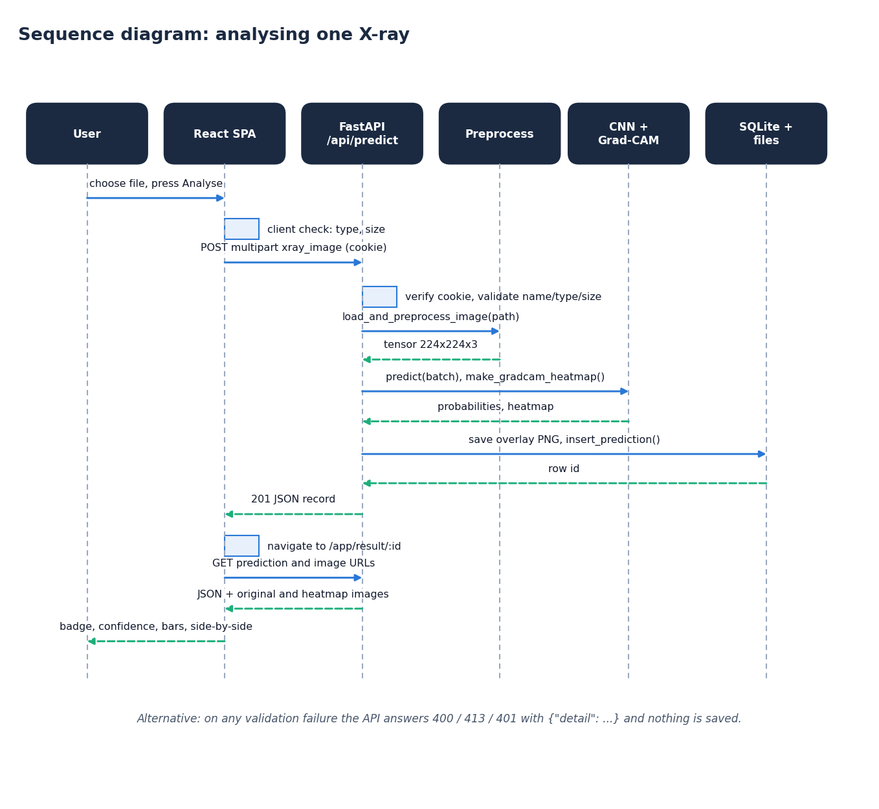
Figure 7: Sequence diagram: analysing one X-ray
The sequence follows one analysis. The React page checks the file type and size, then posts it as multipart data with the session cookie. The API verifies the cookie and validates the upload, calls the preprocessing function, and, under a lock that allows one TensorFlow inference at a time, runs the network and Grad-CAM. It writes the overlay image and the database row and returns HTTP 201 with the full record. The page then navigates to the result route, which fetches the record and the two images and renders the badge, confidence, bars and side-by-side view.

Use-case diagram
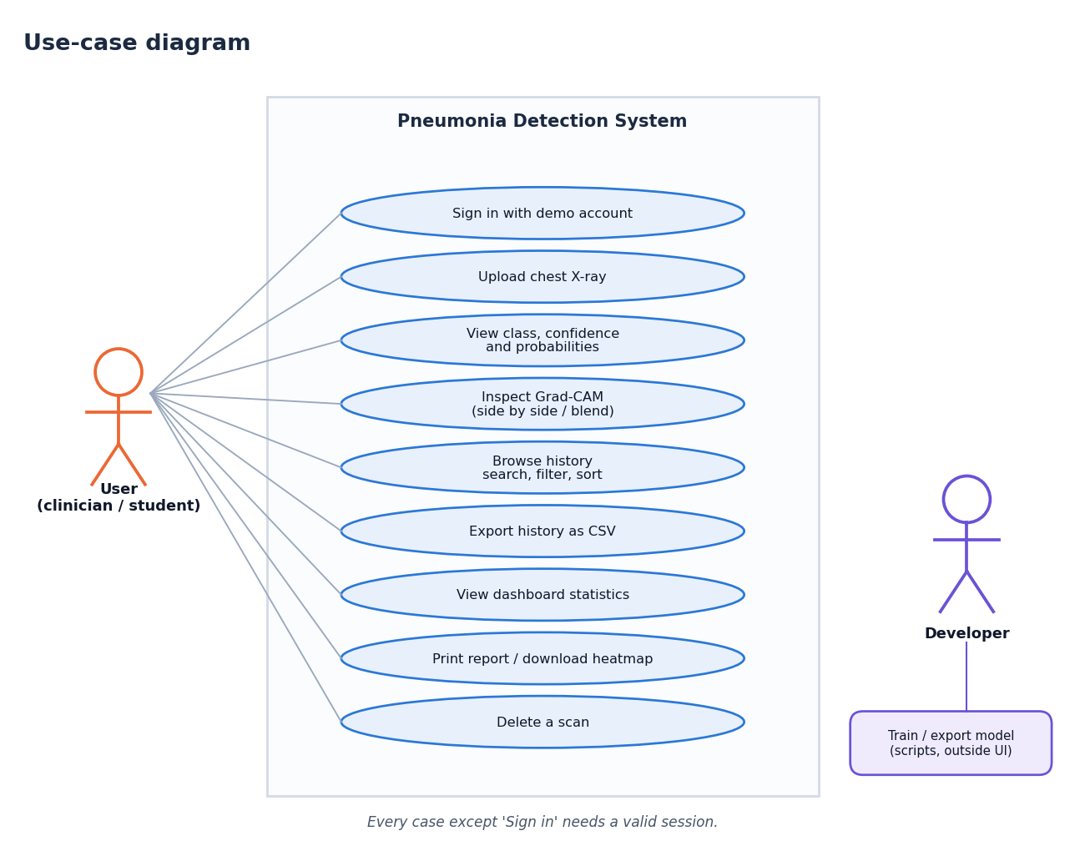
Figure 8: Use-case diagram
The user can sign in, upload an X-ray, view the class, confidence and probabilities, inspect the Grad-CAM overlay (side by side or blended), browse and filter the history, export it as CSV, view dashboard statistics, print the report or download the heat map, and delete a scan. Every case except signing in requires a valid session. The developer is a second actor who trains and exports a model with the scripts, outside the web interface.

Core algorithm flowchart
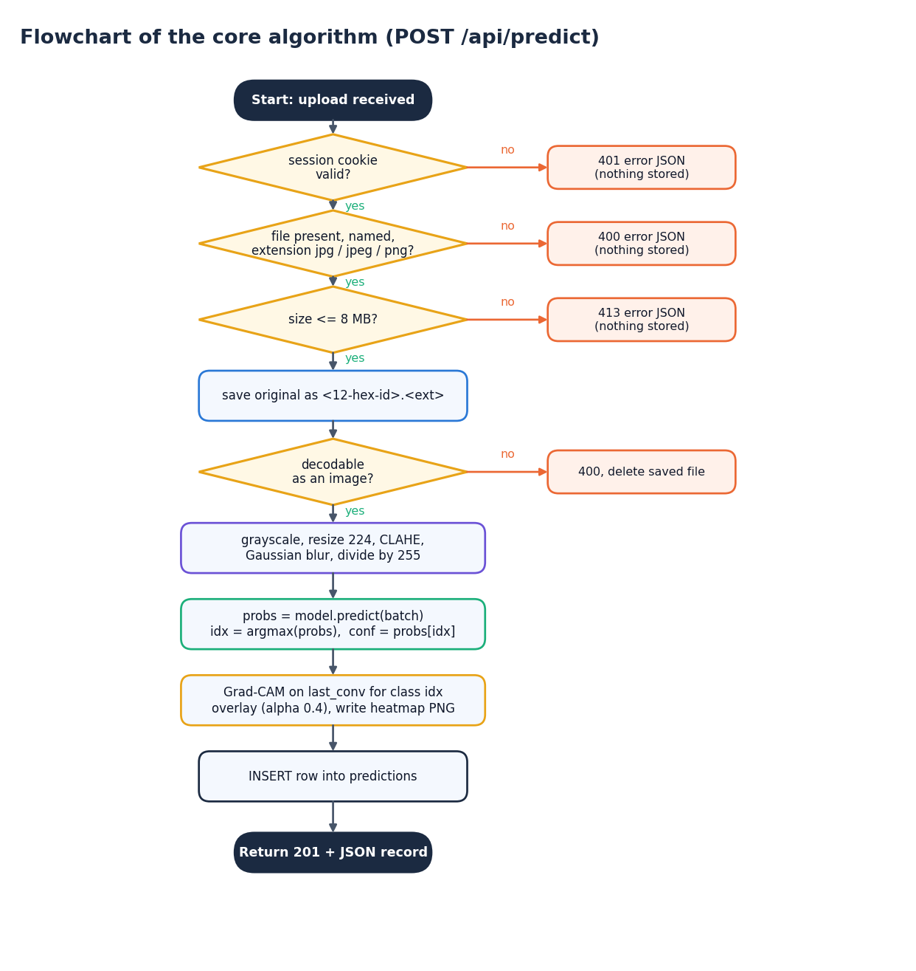
Figure 9: Flowchart of the core algorithm (POST /api/predict)
The flowchart gives the decisions of the prediction route in order: valid session (401 otherwise), a named file with an allowed extension (400), size within 8 MB (413), save under a random 12-character name, decodable image (400, and the saved file is deleted). It then preprocesses, predicts, takes the arg-max, runs Grad-CAM, writes the overlay, inserts the row and returns 201 with the record. The order matches backend/main.py and the Flask route.

5.5 Database design
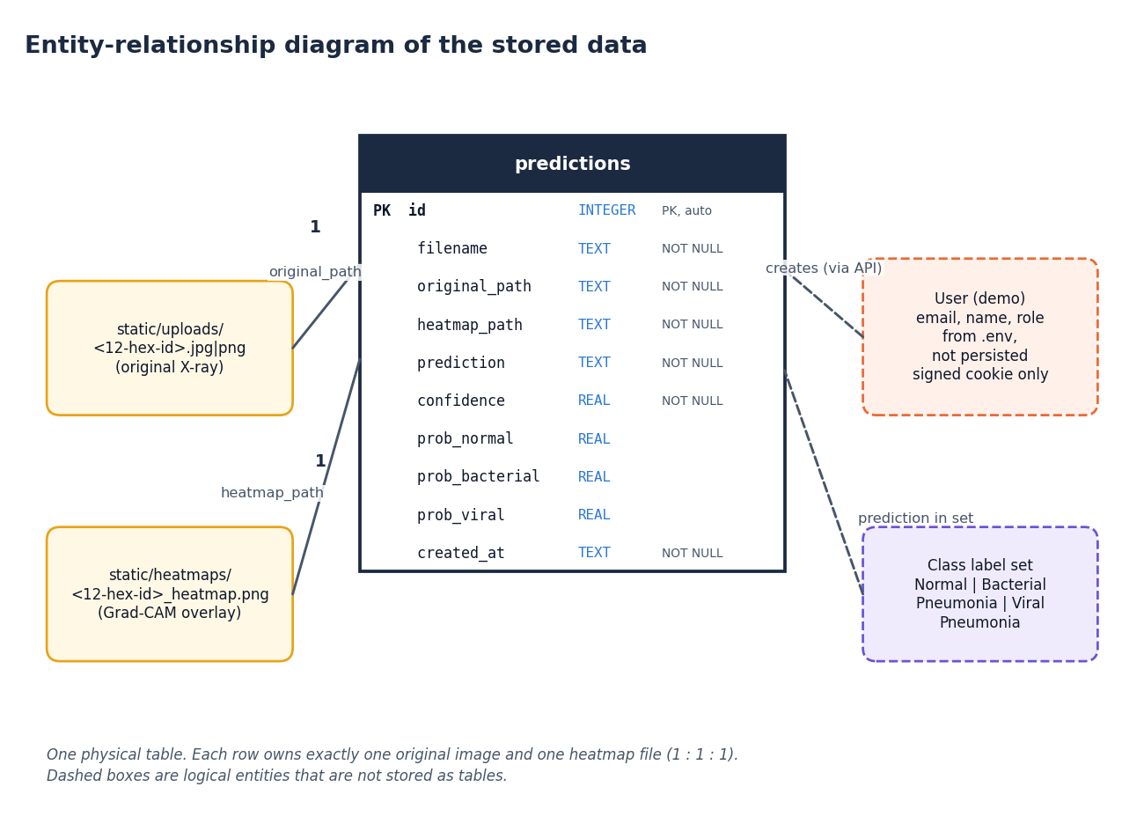
Figure 10: Entity-relationship diagram of the stored data
All persistent data are in one table, predictions, with ten columns. Each row owns exactly one original image in static/uploads/ and one overlay in static/heatmaps/, referenced by relative path, so the relationship between a row and its files is one to one to one. The demo user and the class label set are logical entities: the user is configured through the environment and carried only in a signed cookie, and the label set is the fixed list of three class names.
Table 2: Table predictions
Column | Type | Constraint | Meaning
id | INTEGER | Primary key, auto-increment | Scan number shown in the interface
filename | TEXT | NOT NULL | Original file name as uploaded
original_path | TEXT | NOT NULL | Relative path of the saved original, e.g. uploads/ab12cd34ef56.jpg
heatmap_path | TEXT | NOT NULL | Relative path of the Grad-CAM overlay, e.g. heatmaps/ab12cd34ef56_heatmap.png
prediction | TEXT | NOT NULL | Predicted class name
confidence | REAL | NOT NULL | Probability of the predicted class, 0 to 1
prob_normal | REAL |  | Softmax probability of Normal
prob_bacterial | REAL |  | Softmax probability of Bacterial Pneumonia
prob_viral | REAL |  | Softmax probability of Viral Pneumonia
created_at | TEXT | NOT NULL | UTC timestamp in ISO-8601 form

The table is created by init_db() with CREATE TABLE IF NOT EXISTS, so a fresh checkout needs no migration. All statements use bound parameters (?), never string formatting, which removes SQL injection through file names or ids.

5.6 Module design
Table 3: Modules and responsibilities
Module | Responsibility | Key functions
model/preprocess.py | Image preparation | load_and_preprocess_image, apply_clahe, preprocess_for_display, augmentors
model/model_builder.py | Network definition | build_custom_cnn, build_transfer_model, find_last_conv_layer, CLASS_NAMES
model/gradcam.py | Explanation | make_gradcam_heatmap, overlay_heatmap
model/train.py | Original training script (unchanged) | Keras generators, checkpoint, report
scripts/train_experiment.py | Reproducible experiment runner | patient-level split, class weights, metrics.json, figures
database/db.py | Persistence | init_db, insert_prediction, get_prediction, get_all_predictions
app.py | Original Flask app and model loader | get_model, allowed_file, routes /, /predict, /result/<id>, /history, /about
backend/main.py | FastAPI layer | auth routes, /api/predict, /api/predictions, /api/stats, /api/files, /api/health
frontend/src/pages/* | React screens | Landing, Login, Dashboard, Detect, Result, History, About, NotFound
frontend/src/lib/* | Client logic | api.js (fetch and upload progress), auth.jsx, theme.jsx, format.js, hooks.js
tests/, scripts/*.py | Verification | 73 pytest tests, smoke test, UI verification, screenshot capture

5.7 API design
The API is JSON over HTTP. Errors use the standard FastAPI body {"detail": "message"} with 400 for bad input, 401 for a missing or invalid session, 404 for unknown ids or files and 413 for oversize uploads. The validation order of /api/predict matches the original Flask route, so the same mistake produces the same message in both interfaces.
Table 4: REST endpoints
Method | Path | Session | Purpose
GET | /api/health | No | Status, model readiness, Demo Mode flag, class names, upload limits
POST | /api/auth/login | No | Demo sign-in; sets the signed HttpOnly cookie
POST | /api/auth/logout | No | Clears the cookie
GET | /api/auth/me | No | Signed-in user, or null when signed out
POST | /api/predict | Yes | Multipart xray_image; returns the stored record (201)
GET | /api/predictions?limit= | Yes | History, newest first (limit clamped to 1-1000)
GET | /api/predictions/{id} | Yes | One record; 404 JSON if missing
DELETE | /api/predictions/{id} | Yes | Removes the row and both image files
GET | /api/stats | Yes | Totals, per-class counts, average confidence, 7-day series
GET | /api/files/{uploads|heatmaps}/{name} | Yes | Stored images; basename check blocks traversal

5.8 User interface design
The interface uses the Neo Brutal Grid design kit: thick black outlines, hard offset shadows, a visible grid, an uppercase display typeface for headings and a monospace face for numbers. Colour carries meaning: green for Normal, coral for Bacterial Pneumonia and amber for Viral Pneumonia, and every colour is paired with a label and an icon so the meaning never depends on colour alone. The application shell has a sidebar that becomes a drawer on small screens, a theme toggle that remembers its setting, toast messages, skeleton placeholders and a 404 route.
Table 5: Screens
Screen | Content
Landing / | Public introduction: hero, how it works, the three classes, key figures, disclaimer, call to action
Sign in /login | Demo credentials with a one-click fill button and a show-password option
Dashboard /app | Stat cards, class-distribution and scans-per-day charts, recent scans
Detect /app/detect | File drop area, preview, analyse button with progress, validation messages, Demo Mode alert
Result /app/result/:id | Side-by-side and blended views, class badge, probability bars, scan details, print, download, delete
History /app/history | Search, class filter, sortable paginated table with thumbnails, CSV export, empty state
About /app/about | Abstract, five-step pipeline, technology, disclaimer
Not found * | Friendly 404 with a way back

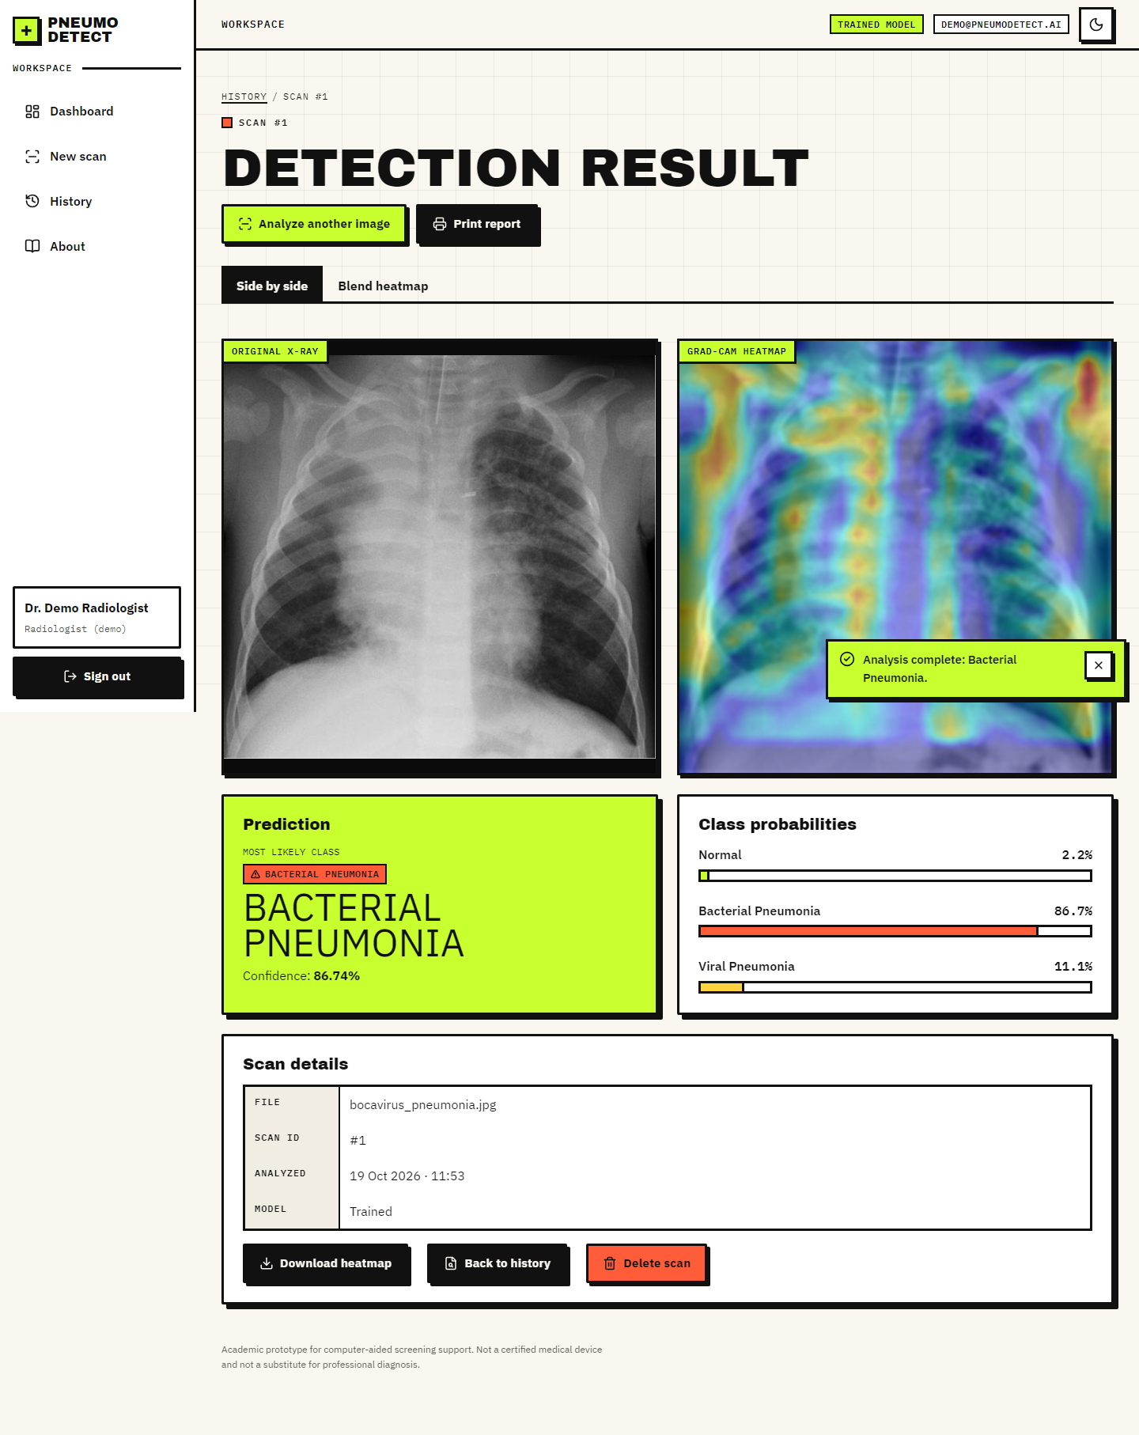
Figure 11: The result screen: side-by-side original and Grad-CAM overlay, class badge and probabilities
Accessibility was designed in rather than added later: visible focus rings, a focus trap in dialogs, the Escape key closing the mobile drawer and the delete dialog, announced loading states, and a reduced-motion mode that keeps all content visible. Chapter 7 reports the automated checks of these properties.

2. IMPLEMENTATION

6.7 Application architecture
backend/main.py creates a FastAPI application (api) whose start-up hook initialises the database and loads the model in a background thread so the first request does not pay the loading cost. It imports app.py and calls get_model() so that the Flask and FastAPI interfaces share one loader, one set of folders and one _demo_mode flag. A threading lock allows only one TensorFlow inference at a time. Cross-origin requests are accepted only from the front-end origin (http://localhost:5312). The React application talks to /api/* through the Vite proxy, so the browser sees one origin and the session cookie is first-party.
The front end is a single-page application built with React 19 and Vite. Routes are code-split and lazy-loaded (the chart library is loaded only by the dashboard). lib/api.js wraps fetch, turns every error response into an ApiError with the server's message and uses an XMLHttpRequest for uploads so the progress bar can show real upload progress; a 401 anywhere returns the user to the sign-in page.

6.8 API design
Section 5.7 lists the ten endpoints. The prediction route validates in a fixed order (no file, empty name, unsupported extension, size above 8 MB, unreadable image), saves the original under a random 12-character name, preprocesses, runs the network and Grad-CAM under the lock, writes the overlay, inserts the database row and returns the stored record with status 201. The record contains the probabilities as an object keyed by class name, image URLs under /api/files/, an ISO timestamp with a trailing Z and the demo_mode flag.
@api.post("/api/predict", status_code=201)
def predict(xray_image: UploadFile = File(None), user=Depends(current_user)):
if xray_image is None: bad(400, "No file part in the request.")
if not xray_image.filename: bad(400, "Please choose an X-ray image to upload.")
if not flask_app.allowed_file(xray_image.filename):
bad(400, "Unsupported file type. Please upload a JPG or PNG image.")
data = xray_image.file.read(MAX_BYTES + 1)
if len(data) > MAX_BYTES: bad(413, "File is too large. The limit is 8 MB.")
...
with _predict_lock:
probs = model.predict(batch, verbose=0)[0]
pred_idx = int(np.argmax(probs))
heatmap, _ = make_gradcam_heatmap(batch, model, flask_app._last_conv_layer, pred_index=pred_idx)
...
return serialize(db.get_prediction(pred_id))

6.9 Security and error handling
Table 6: Controls
Threat or fault | Control in the code
Unauthenticated access | Every route except health, login, logout and /api/auth/me depends on current_user, which reads a signed cookie and answers 401
Cookie forgery or tampering | Cookie = base64 payload + HMAC-SHA256 signature checked with hmac.compare_digest; payload carries an expiry (12 h)
Script access to the session | Cookie set HttpOnly and SameSite=Lax
Path traversal on file routes | Only uploads and heatmaps are served and the name must equal its own basename
SQL injection | All SQL uses bound parameters
Hostile or huge uploads | Extension allow-list, 8 MB limit read incrementally (413), decode check (400) with deletion of the saved file
Concurrent inference | A lock serialises TensorFlow calls
Cross-site requests | CORS limited to the front-end origin, credentials allowed only for it
Credentials in source control | .env is git-ignored; .env.example documents the variables; the demo password is shown on the sign-in page because it is a demonstration account
Unreadable or missing model | The loader builds an untrained network and the interface shows a Demo Mode warning on every relevant screen

Known weaknesses are stated in Section 1.8: the demo account is shared, the transport is plain HTTP on localhost, and the original Flask application keeps a fixed secret key and no login.

6.10 Installation and execution
run.bat reads the ports from .env (API 8312, UI 5312), creates a .venv if needed, installs requirements.txt and requirements-api.txt, runs npm install in frontend/ on first use, opens two console windows (the API and the UI) and then the browser. stop.bat closes them. run.bat flask starts the original Flask interface on port 5000. Appendix B gives the full user guide and the manual commands.

3. KEY CODE WALK-THROUGHS

3.1 Preprocessing: one function for training and serving
load_and_preprocess_image accepts a path or raw bytes, so the API can decode an upload without writing it first and the training script can read from disk with the same code.
def load_and_preprocess_image(path_or_bytes, apply_enhancement: bool = True) -> np.ndarray:
"""
Load an image from a file path (or raw bytes buffer), preprocess it,
and return a float32 array of shape (224, 224, 3) normalized to [0, 1].
"""
if isinstance(path_or_bytes, (bytes, bytearray)):
arr = np.frombuffer(path_or_bytes, dtype=np.uint8)
img = cv2.imdecode(arr, cv2.IMREAD_GRAYSCALE)
else:
img = cv2.imread(str(path_or_bytes), cv2.IMREAD_GRAYSCALE)

if img is None:
raise ValueError(f"Could not read image: {path_or_bytes}")

# Resize to model input size
img = cv2.resize(img, IMG_SIZE, interpolation=cv2.INTER_AREA)

# Contrast Limited Adaptive Histogram Equalization
if apply_enhancement:
img = apply_clahe(img)

# Mild denoising (helps with scanner/JPEG artefact noise)
img = cv2.GaussianBlur(img, (3, 3), 0)

# Grayscale -> 3-channel so it can feed either a custom CNN or a
# transfer-learning backbone (DenseNet/ResNet/EfficientNet all expect 3ch)
img_rgb = cv2.cvtColor(img, cv2.COLOR_GRAY2RGB)

# Normalize to [0, 1]
img_norm = img_rgb.astype("float32") / 255.0

return img_norm

3.2 Grad-CAM
A second model maps the input to the last convolutional feature maps and the output; the gradient of the chosen class score with respect to those maps gives the channel weights. Because the function needs the feature tensor to be connected to the model input, it works on a flat network and fails on a nested backbone.
def make_gradcam_heatmap(img_array, model, last_conv_layer_name, pred_index=None):
"""
img_array: shape (1, H, W, 3), already preprocessed/normalized.
Returns a 2D heatmap (values in [0, 1]) the same spatial size as the
last convolutional feature map.
"""
grad_model = tf.keras.models.Model(
model.inputs, [model.get_layer(last_conv_layer_name).output, model.output]
)

with tf.GradientTape() as tape:
conv_outputs, predictions = grad_model(img_array)
if pred_index is None:
pred_index = tf.argmax(predictions[0])
class_channel = predictions[:, pred_index]

grads = tape.gradient(class_channel, conv_outputs)
pooled_grads = tf.reduce_mean(grads, axis=(0, 1, 2))

conv_outputs = conv_outputs[0]
heatmap = conv_outputs @ pooled_grads[..., tf.newaxis]
heatmap = tf.squeeze(heatmap)

heatmap = tf.maximum(heatmap, 0) / (tf.math.reduce_max(heatmap) + 1e-8)
return heatmap.numpy(), int(pred_index)

3.3 Prediction route
The route validates in a fixed order, saves the upload under a random name, preprocesses, runs the network and Grad-CAM under a lock, writes the overlay and the row, and returns the stored record.
@api.post("/api/predict", status_code=201)
def predict(xray_image: UploadFile = File(None), user=Depends(current_user)):
# same validation order as the Flask /predict route
if xray_image is None:
bad(400, "No file part in the request.")
if not xray_image.filename:
bad(400, "Please choose an X-ray image to upload.")
if not flask_app.allowed_file(xray_image.filename):
bad(400, "Unsupported file type. Please upload a JPG or PNG image.")
data = xray_image.file.read(MAX_BYTES + 1)
if len(data) > MAX_BYTES:
bad(413, f"File is too large. The limit is {MAX_BYTES // (1024 * 1024)} MB.")

model = flask_app.get_model()
ext = xray_image.filename.rsplit(".", 1)[1].lower()
unique_id = uuid.uuid4().hex[:12]
saved_name = f"{unique_id}.{ext}"
saved_path = os.path.join(flask_app.UPLOAD_FOLDER, saved_name)
with open(saved_path, "wb") as f:
f.write(data)

try:
preprocessed = load_and_preprocess_image(saved_path)
display_img = preprocess_for_display(saved_path)
except ValueError:
os.remove(saved_path)
bad(400, "That file could not be read as an image. Try another X-ray.")
batch = np.expand_dims(preprocessed, axis=0)

with _predict_lock:
probs = model.predict(batch, verbose=0)[0]
pred_idx = int(np.argmax(probs))
heatmap, _ = make_gradcam_heatmap(batch, model, flask_app._last_conv_layer, pred_index=pred_idx)

names = flask_app._class_names
prob_map = {n: float(p) for n, p in zip(names, probs)}
overlay = overlay_heatmap(display_img, heatmap, alpha=0.4)
heatmap_name = f"{unique_id}_heatmap.png"
cv2.imwrite(os.path.join(flask_app.HEATMAP_FOLDER, heatmap_name), cv2.cvtColor(overlay, cv2.COLOR_RGB2BGR))

pred_id = db.insert_prediction(
filename=xray_image.filename,
original_path=f"uploads/{saved_name}",
heatmap_path=f"heatmaps/{heatmap_name}",
prediction=names[pred_idx],
confidence=float(probs[pred_idx]),
prob_normal=prob_map.get("Normal", 0.0),
prob_bacterial=prob_map.get("Bacterial Pneumonia", 0.0),
prob_viral=prob_map.get("Viral Pneumonia", 0.0),
)
return serialize(db.get_prediction(pred_id))

3.4 Signed session cookie
The session is stateless: the cookie carries the e-mail and an expiry, signed with HMAC-SHA256, verified with a constant-time comparison.
def _sign(payload: str) -> str:
return hmac.new(SESSION_SECRET, payload.encode(), hashlib.sha256).hexdigest()

def make_token(email: str) -> str:
body = base64.urlsafe_b64encode(json.dumps({"e": email, "x": int(time.time()) + SESSION_TTL}).encode()).decode()
return f"{body}.{_sign(body)}"

def read_token(token):
if not token or "." not in token:
return None
body, sig = token.rsplit(".", 1)
if not hmac.compare_digest(sig, _sign(body)):
return None
try:
data = json.loads(base64.urlsafe_b64decode(body.encode()))
except Exception:
return None
return data if data.get("x", 0) > time.time() else None

def current_user(request: Request):
data = read_token(request.cookies.get(COOKIE))
if not data:
raise HTTPException(401, "Please sign in to continue.")
return {"email": data["e"], "name": DEMO_NAME, "role": DEMO_ROLE}

3.5 Patient-level split in the training script
if args.protocol == "official":
sgkf = StratifiedGroupKFold(n_splits=10, shuffle=True, random_state=SEED)
tr_idx, va_idx = next(sgkf.split(pool, y_pool, groups))
assert not set(groups[tr_idx]) & set(groups[va_idx]), "patient leakage between train and validation"
X_tr, y_tr, g_tr = X_pool[tr_idx], y_pool[tr_idx], groups[tr_idx]
X_va, y_va, g_va = X_pool[va_idx], y_pool[va_idx], groups[va_idx]
else: # patient-disjoint re-partition of all 5,856 images
all_paths = pool + test_paths
X_all = np.concatenate([X_pool, X_test])
y_all = np.concatenate([y_pool, y_test])
g_all = np.concatenate([groups, groups_test])
outer = StratifiedGroupKFold(n_splits=7, shuffle=True, random_state=SEED)
rest_idx, te_idx = next(outer.split(all_paths, y_all, g_all))
inner = StratifiedGroupKFold(n_splits=6, shuffle=True, random_state=SEED)
tr_rel, va_rel = next(inner.split(rest_idx, y_all[rest_idx], g_all[rest_idx]))
tr_idx, va_idx = rest_idx[tr_rel], rest_idx[va_rel]
assert not (set(g_all[tr_idx]) & set(g_all[va_idx])) and not (set(g_all[tr_idx]) & set(g_all[te_idx])) and not (set(g_all[va_idx]) & set(g_all[te_idx])), "patient leakage between splits"
X_tr, y_tr, g_tr = X_all[tr_idx], y_all[tr_idx], g_all[tr_idx]
X_va, y_va, g_va = X_all[va_idx], y_all[va_idx], g_all[va_idx]
X_test, y_test = X_all[te_idx], y_all[te_idx]
test_paths = [all_paths[i] for i in te_idx]
groups_test = g_all[te_idx]

if args.smoke:
keep = np.random.RandomState(SEED).permutation(len(y_tr))[:200]
X_tr, y_tr, g_tr = X_tr[keep], y_tr[keep], g_tr[keep]
args.epochs, args.head_epochs = 1, 1

4. IMPLEMENTATION DECISIONS AND THEIR REASONS
Table 7: Decisions and reasons
Decision | Alternatives considered | Reason | Consequence
Keep the original Flask app untouched; add FastAPI beside it | Rewrite the back end; port the model code | No logic needed to change; both interfaces share one model loader | Two entry points to maintain, one model implementation
Signed HttpOnly cookie for the demo login | Bearer token in localStorage | <img> tags cannot send headers, and the images are behind the login; HttpOnly keeps the token away from scripts | Needs a proxy or same-origin setup (provided by Vite)
Custom CNN as the deployed model | DenseNet / EfficientNet / MobileNetV3Small | Small, CPU-trainable, flat so Grad-CAM works | Lower ceiling than transfer learning
CLAHE in training and inference | No enhancement | Standard for radiographs; the inference path already used it; ablation measures the effect | Slight extra cost per image
Patient-level validation split | Random image split | Several images belong to one patient; a random split leaks | Slightly noisier validation
Balanced class weights | Resampling | Bacterial images are twice as frequent; weights keep every image | Loss values not comparable to unweighted runs
Report on id-disjoint and patient-level protocols as well | Report only the official test split | The official split shares pneumonia ids with training | More numbers to explain; fewer misleading ones
SQLite with one table | PostgreSQL, multiple tables | One entity; zero administration | Not built for many concurrent users
Vite proxy for /api | CORS-only, cross-origin cookies | One origin, first-party cookie, simpler | Production would need a reverse proxy
Demo Mode when weights are missing | Refuse to start | Lets anyone run the pipeline; a banner states the limitation | Predictions meaningless until trained

